1. Which is the basic operation of lin search, bin search and lin auto search?

In the three searches the basic operation is the comparation inside the loops. In our case, for bin_search is the comparation inside the while loop and for the other two, the comparation inside the for loop.

1. Give the execution times, in terms of the input size *n* for the worst *WSS*(*n*) and best *BSS*(*n*) cases of **bin search** and **lin search**. Use the asymptotic notation (*O,*Θ*,o,*Ω,etc) as long as you can.

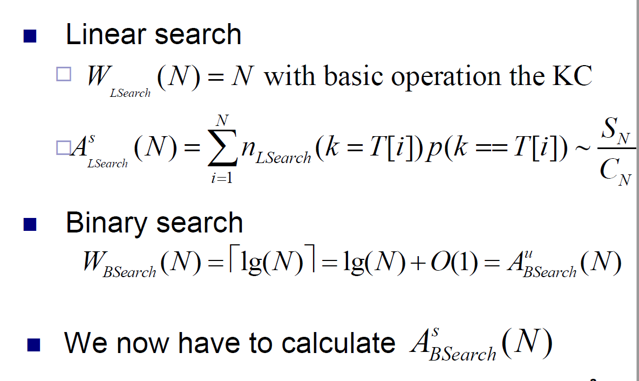

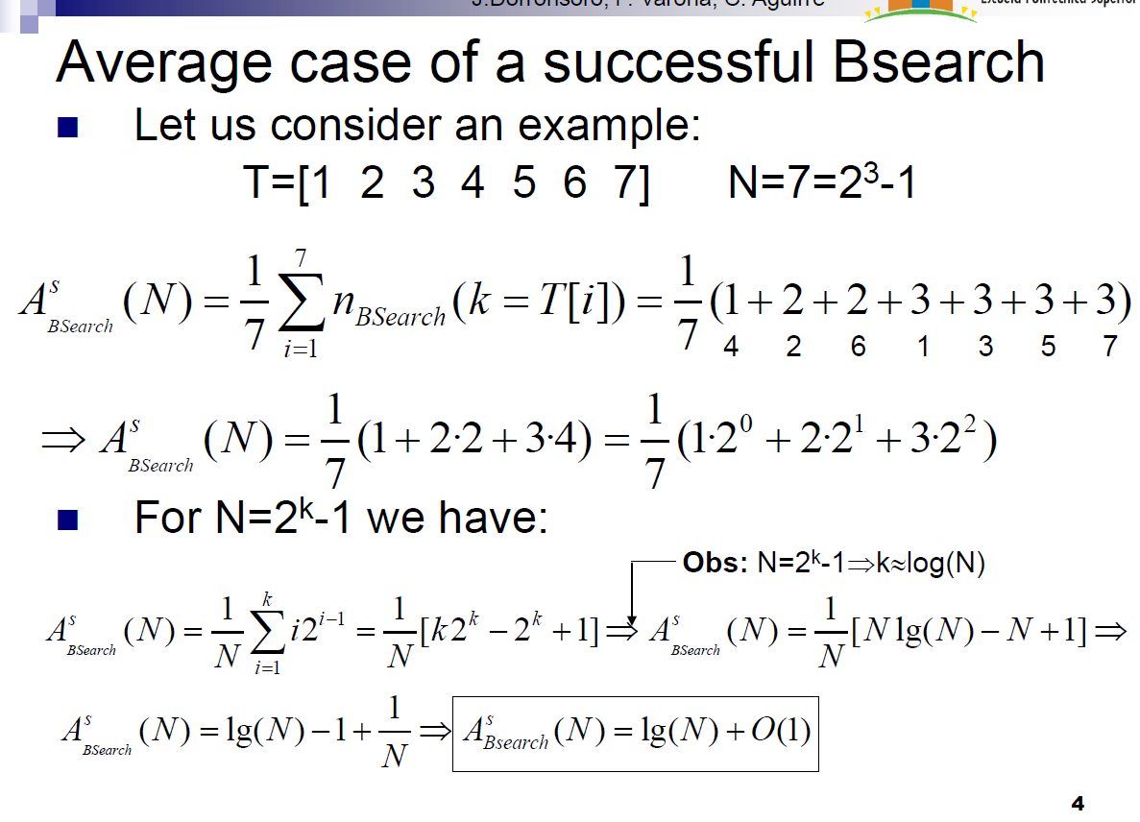

1. When **lin auto search** and the given not-uniform key distribution are used, how does it vary the position of the elements in the list of keys as long as the number of searches increases?
2. Which is the average execution time of **lin auto search** as a function of the number of elements in the dictionary *n* for the given not uniform key distribution? Consider that a large number of searches have been conducted and the list is in a quite stable state.
3. Justify as formally as you can the correction (in other words, why it searches well) of the **bin search** algorithm.